Texas Instruments, Inc.
DC101A - AFE7920 EVM
Basic EVM Test Procedures
JESD204B and AC Performance Test Procedure
Version 1.1
Kang Hung Hsia
9/11/2019

Change History:

Date | Version | Changes | Reason | By
09/05/2019 | 1.0 | - Initial Revision |  | Kang Hsia
09/11/2019 | 1.1 | - Added basic 5V power supply current draw during power supply test.  - Added note about USB LED D10 brightness and resolution using shorter USB cable.  - Updated J17 CPLD Programmer Pin 1 Location.  - Added configuration scripts to change NCO, FB path, and recover to RX/TX path | Clarification to the test procedure and also additional features to streamline test time. | Kang Hsia

Overall Goal:
There are two sets of the test procedures in this document, and they are described as following:
- Basic EVM Test Procedures: this set of tests provides basic EVM functional test such as EVM power supply rails check, FTDI USB chip programming, and CPLD firmware programming.
- JESD204B and AC Performance Test Procedures: this set of tests provides advanced EVM testing such as checking the JESD204B link connection between the TSW14J56 EVM and the AFE7920 EVM, and the AFE7920 EVM ADC and DAC performance testing.
- The test facilities can perform the Basic EVM Test Procedures on one batch of boards before performing the JESD204B/AC Performance Test Procedure on the same batch of boards. The two sets of tests can also be combined into a single set of tests. This is left at the discretion of the test facilities in terms of test efficiency.

SAFETY
- Safety Glasses are to be worn.
- This test must be performed by qualified personnel trained in electronics theory and understand the risks and hazards of the assembly to be tested.
- ESD precautions must be followed while handling electronic assemblies while performing this test.
- Precautions should be observed to avoid touching areas of the assembly that may get hot or present a shock hazard during testing.
- NO ESD wrist strap shall be worn for Hi Voltage testing (=>50 Vrms or =>75 VDC) use Ionizer.

QUALITY
Test data or reports shall be made available upon request by Texas Instruments.

APPAREL
- Electrostatic smock
- Electrostatic Gloves or finger cots
- Safety Glasses
- Ground ESD wrist strap

Start of Basic EVM Test Procedures.

Test Equipment Required:
- DC Power Supply at 5.5V, 5A
- DC Multi-meter
- USB Mini-B Cable
- PC with USB Port
- Intel USB Blaster or USB Blaster II

Software Required:
- FTDI FT_PROG USB Device Programmer
- Intel Quartus Prime Programmer

Files Requires:
- AFE79xx CPLD Firmware.pof
- AFE79xx EVM FTDI Programming.xml

Power Supply Check
- Connect 5V power supply to power jack (PWR_JACK) connector (J18) of the AFE7920 EVM. The 5V supply may be elevated to 5.5V if there is sufficient power cable loss associated with the setup.
Check: D9 (PWR) LED should lit up.
The power supply should draw about 550mA to 650mA
- Connect USB Type Mini-B Cable from PC to the USB port (J19) of the AFE7920 EVM.
Check: D10 (USB_PWR) LED should lit up. The LED light may be weak depending on the USB cable length. If the LED is not lit up, please use a shorter USB cable. TI had tested three foot long USB cable in this setup.
- The power supply sequencer on the AFE7920 EVM has power status for each rail. If the power good (PGOOD) is in logic HI, the corresponding power supply rail is powered correctly. The respective LED will light up.
Check: D5 (1P8) LED, D6 (1P2) LED, D7 (0p9) LED, and D8 (3p3_LMK) LED should lit up.
All LEDs are shown in Figure 1
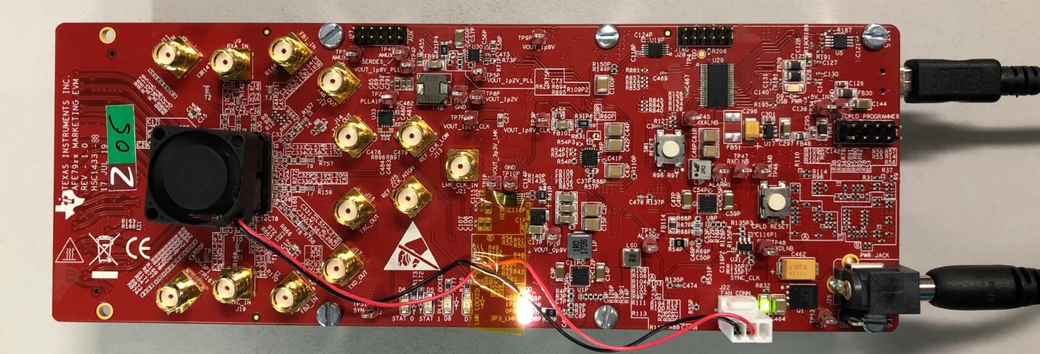
Figure 1. PWR LED, USB PWR, and Sequencer LED check
- Use a digital multi-meter to check the power supply voltages for each rail. The corresponding voltage and test points are shown in Figure 2 and Table 1.
Table 1. Power Supply Rails Voltage Check Points
Test Point | Node Description | Voltage (V)  Min | Voltage (V) Nominal | Voltage (V) Max
TP10 | VOUT_3p3V_LMK | 3.25 | 3.3 | 3.35
TP14 | VOUT_0p9V | .93 | 0.95 | 0.97
TP8 | VOUT_1p2V | 1.17 | 1.2 | 1.23
TP7 | VOUT_1p2V_CLK | 1.17 | 1.2 | 1.23
TP9 | VOUT_1p2V_PLL | 1.17 | 1.2 | 1.23
TP13 | VOUT_1p8V_CLK | 1.77 | 1.8 | 1.85
TP5 | VOUT_1p8V_PLL | 1.77 | 1.8 | 1.85
TP3 | PLLA1p8V | 1.77 | 1.8 | 1.85

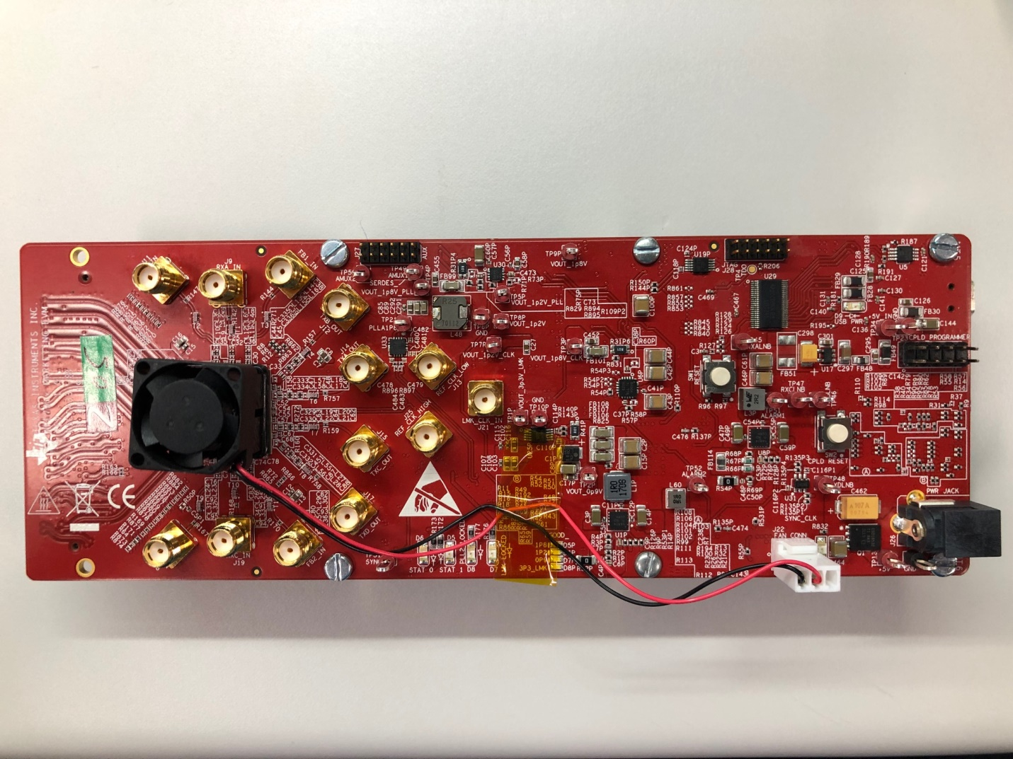
Figure 2. Power Supply Voltage Check

USB Programming
- With the PC connected to the AFE79xx EVM through USB Mini- B cable, open the FTDI FT_PROG software.
- Ensure only the keyboard and the mouse are connected. Ensure other USB devices such as Intel USB Blaster and USB Blaster II are disconnected to avoid accidental programming of other USB devices
- On the FT_PROG software, click on “Scan and Parse” button, as shown in Figure 3.
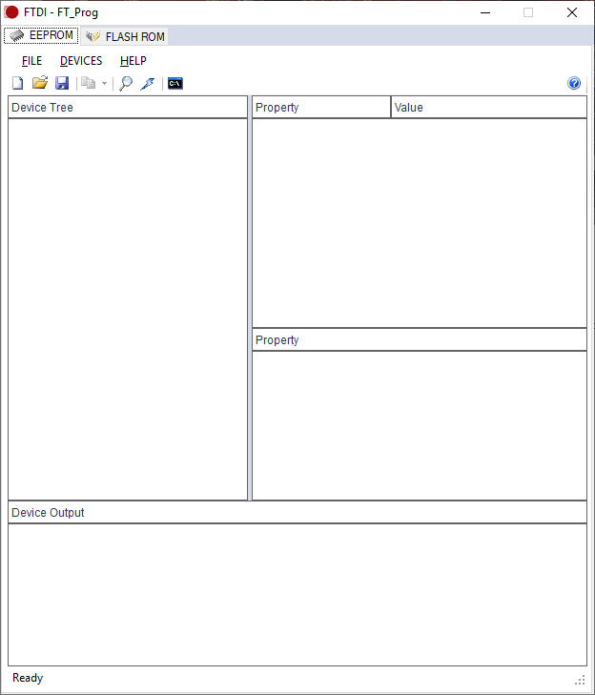
Figure 3. Press Scan and Parse to Detect USB Connection to AFE79xx EVM
- Right click on Device 0 after the Scan and Parse action. Click on “Apply Template”, and load the template “AFE79xx EVM FTDI Programming.xml” as shown in Figure 4.
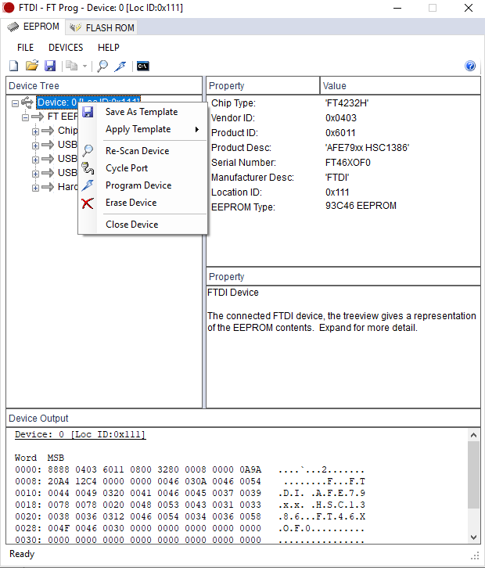
Figure 4. Apply AFE7920 EVM USB Device Template
- Click on “Program Device” to complete the programming of the AFE7920 EVM USB device as shown in Figure 5.
Figure 5. Apply AFE7920 EVM Template

CPLD Programming
- Open the Intel Quartus Prime Programmer software. Click on “Add File” button. On the file load menu, open “AFE79xx CPLD Firmware.pof” as shown in Figure 6
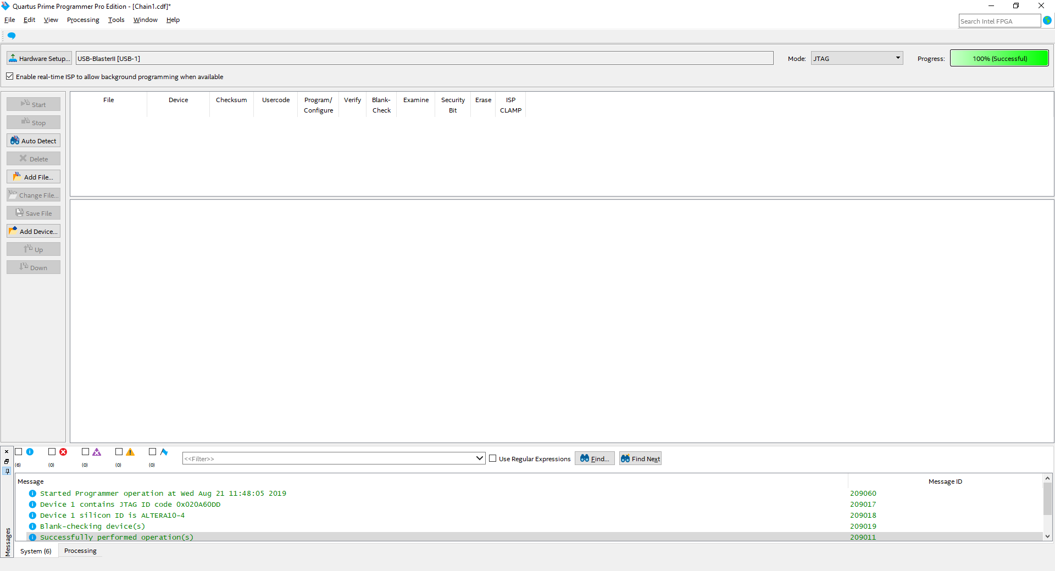
Figure 6. Intel Quartus Prime Programmer “Add File”
- Connect Intel USB Blaster or USB Blaster II programmer to J17 CPLD PROGRAMMER header. Pin “1” is located in Figure 7
1
Figure 7. Pin 1 of J17 CPLD PROGRAMMER Header
- The final connection is shown in Figure 8
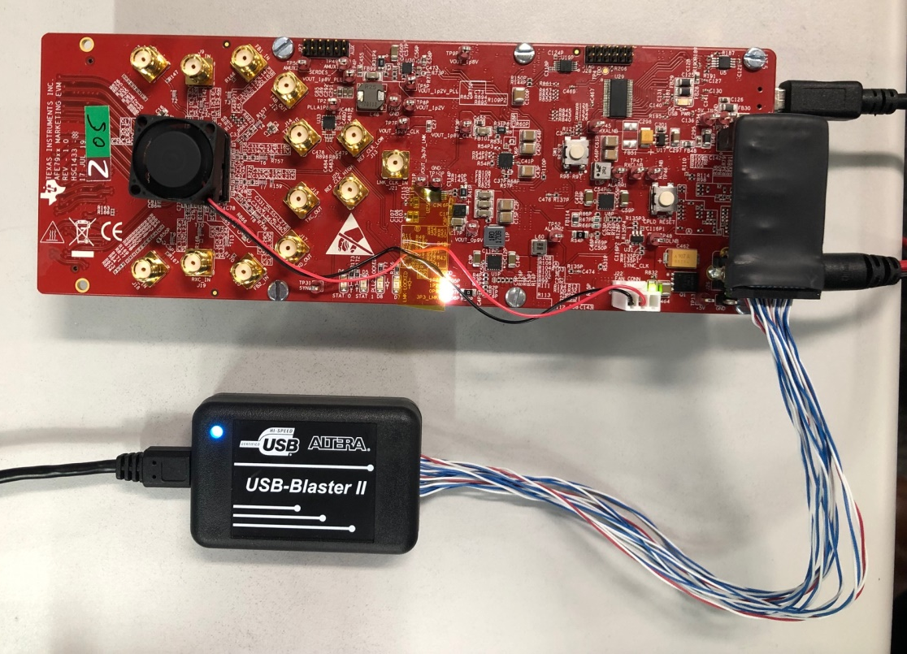
Figure 8. Connection of USB Blaster II to J17 CPLD Programmer Header
- Press “start” to complete the CPLD programming. Check for errors after programming completes. Once completes, the status will be shown as 100%, as shown in Figure 9.

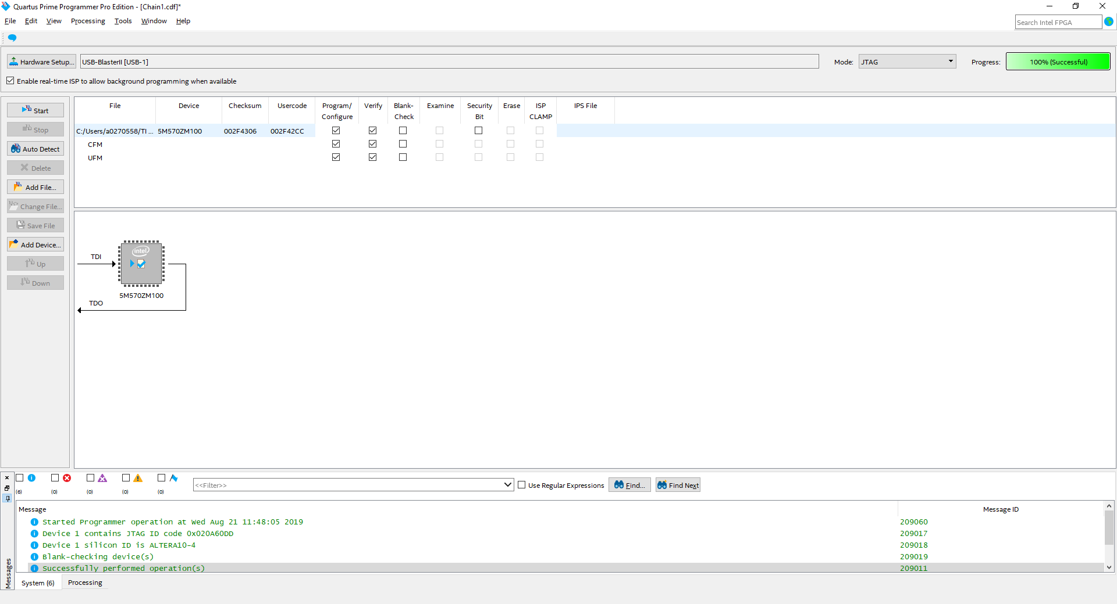
Figure 9. Intel Quartus Prime Programmer "Start"

End of Basic EVM Test Procedures.

Start of EVM Performance Test Procedures.

Recommended Test Environment
- Power Supply at 5.5V, 4A maximum
- Power Supply at 5.5V, 3A maximum
- PC supporting USB 3.0 for fast file transfer from ADC capture
- High quality RF signal generator supporting RF frequency of interest for evaluation
- High quality RF spectrum analyzer supporting RF frequency of interest for evaluation.

Required Hardware and Software
  - Hardware Required
- TSW14J56 EVM
- AFE79xx EVM Rev A
- USB 3.0 cable
- USB 2.0 Mini-B cable
- Two power supply cables

  - Software Installer
- AFE79xxEVM_GUIv1p4p4p1.exe
- High Speed Data Converter Pro Software
http://www.ti.com/tool/DATACONVERTERPRO-SW
- Additional Files
  - AFE79xx_DC101A_NCO_Setup.py (to set up the NCO for DC101A)
  - AFE79xx_FB_Capture.py (to set up the FB path for FB ADC capture)
  - AFE79xx_RecoverRXTX.py (to recover back to RX and TX evaluation)

Test Setup and Procedure
  - Hardware Setup:
- Connect FMC connector U31 of AFE79xx EVM to FMC connector J4 of TSW14J56 EVM.
- With the power supply in powered down mode, connect 5.5V, 3A maximum power supply to J11 “+5V IN” connector of the TSW14J56EVM.
- Connect USB 3.0 cable from the PC to J9 connector of the TSW14J56 EVM.
- With the power supply in powered down mode, connect 5.5V, 4A maximum power supply to J18 “CONN JACK PWR” connector of the AFE79xx EVM.
- Connect USB 2.0 cable from the PC to J19 connector of the AFE79xx EVM.
- All connection shown in Figure 10.

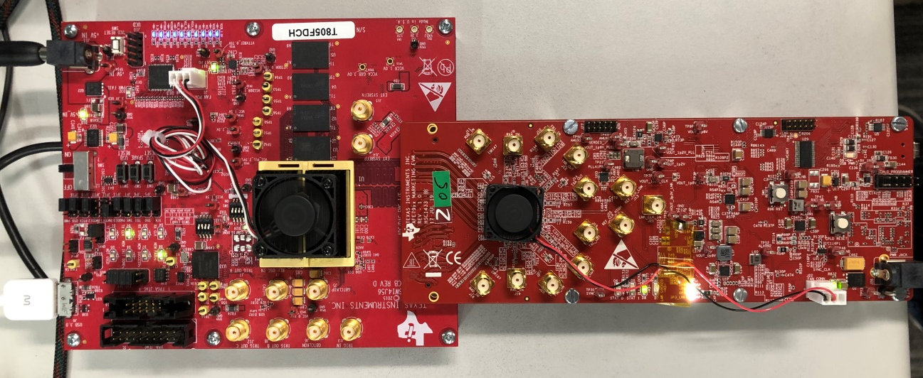
Figure 10. Test Setup.
  - Software Setup:
- Install High Speed Data Converter Pro software. Follow all the instructions within the installer execution process.
Please note the directory to which the High Speed Data Converter Pro software is installed.
- Install AFE79xxEVM_GUIv1p4p4p1.exe. Follow all the instructions within the installer execution process. The installer will install the following:
  - Latte 5.2.3
  - AFE79xx Latte Library v1.4
  - NI Labview Runtime Engine 2014
  - Associated HSDC PRO INI Files required for AFE79xx EVM.
Please note the directory to which the Latte software is installed.
- Place the following three automation files specifically for the DC101A EVM into the following directory:
  - AFE79xx_DC101A_NCO_Setup.py (to set up the NCO for DC101A)
  - AFE79xx_FB_Capture.py (to set up the FB path for FB ADC capture)
  - AFE79xx_RecoverRXTX.py (to recover back to RX and TX evaluation)

Place into C:\Users\ “User ID” \Documents\Texas Instruments\Latte\projects\AFE79xx\Automation. Please replace “User ID” with proper login ID of the Windows login.

  - Quick Start Procedure
- Within the Windows PC, start the HSDC PRO software by going to Start > Texas Instruments > High Speed Data Converter Pro. Ensure that the High Speed Data Converter Pro had started properly.
Please note the Serial Numbers of the TSW14J56 EVM once connected.

- Press “OK” to proceed the connection to the TSW14J56 EVM to the PC. 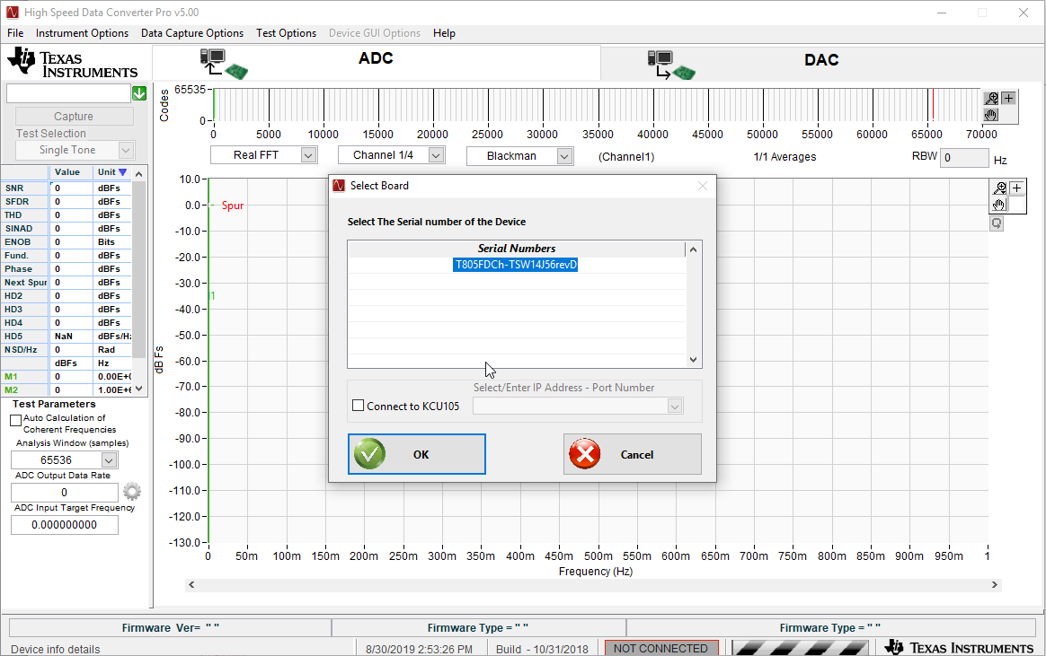
Figure 11. TSW14J56EVM Serial Number upon the Launch of High Speed Data Converter Pro
- Within the Windows PC, start the Latte software by going to Start > Texas Instruments > Latte. Ensure that the Latte software had started properly.
- On the left hand side of the Latte, within Scripts window, expand AFE79xx > Automation > AFE79xx_TSW14J56_Mode1.py. The python script is shown in Figure 12
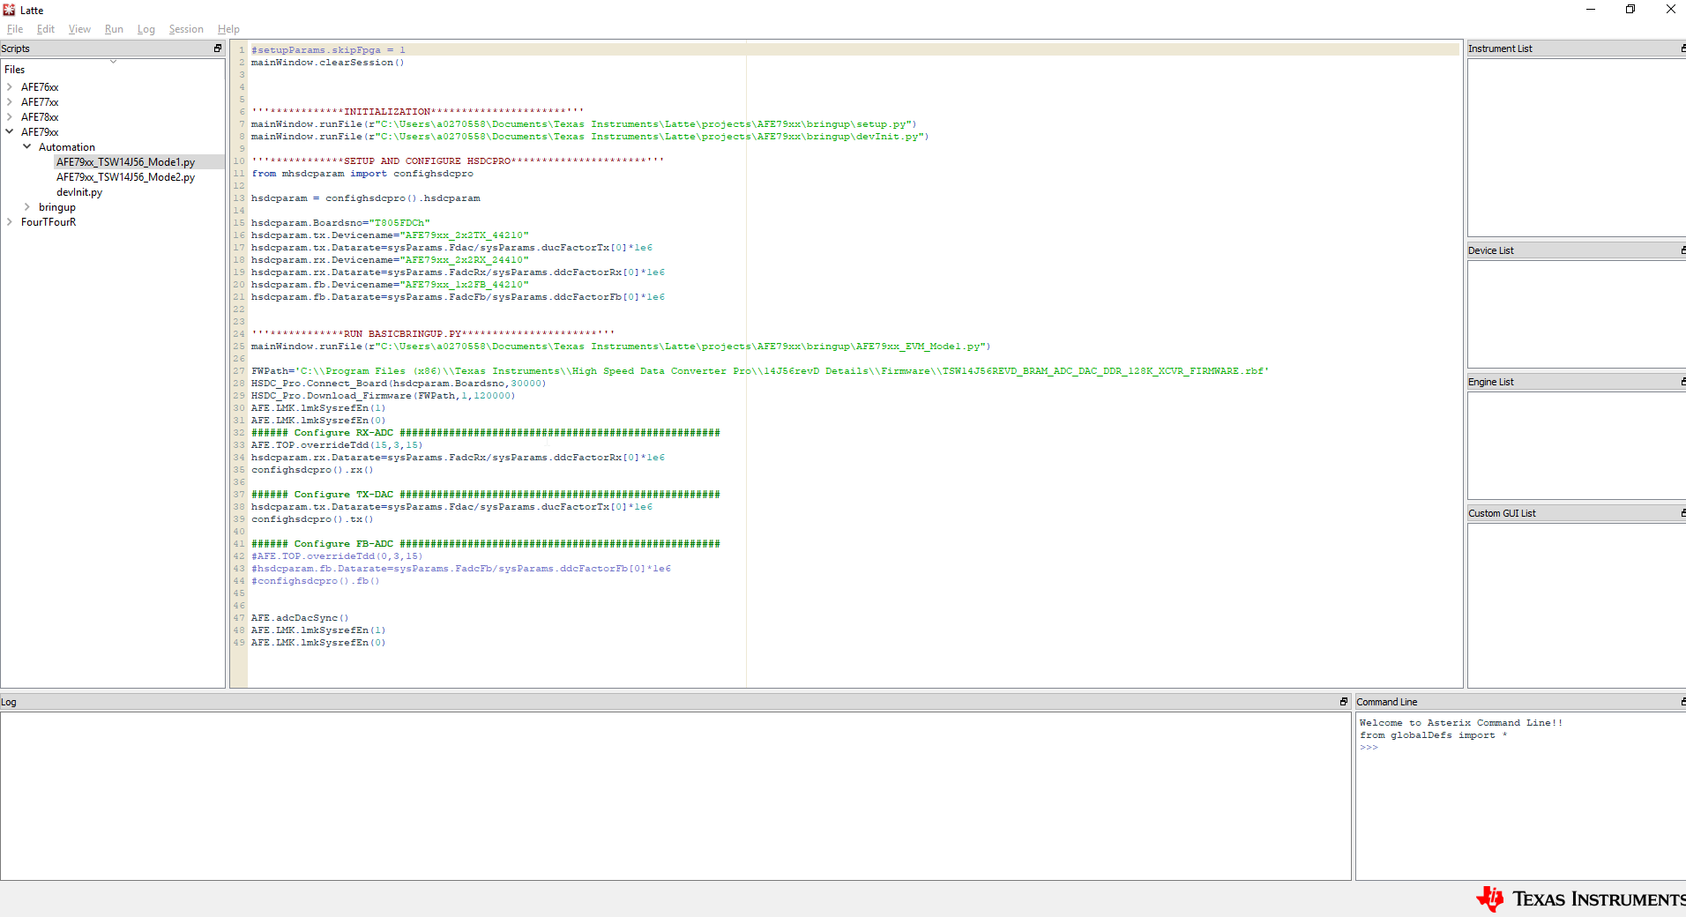
Figure 12. Latte Software AFE79xx_TSW14J56_Mode1.py
- Three parameters within the AFE79xx_TSW14J56_Mode1.py need to be changed per the directory being used by the High Speed Data Converter Pro software and the Latte software
  - Please change item #1 and #2 as highlighted in Figure 13 below to reflect the location of the Latte install directory for the setup.py and devInit.py.
Usually the area where “a0270558” need to be replaced with user ID of Windows Login.
  - Please change item #3 as highlighted in Figure 13 below to reflect the location of the High Speed Data Converter Pro directory for the TSW14J56 firmware.
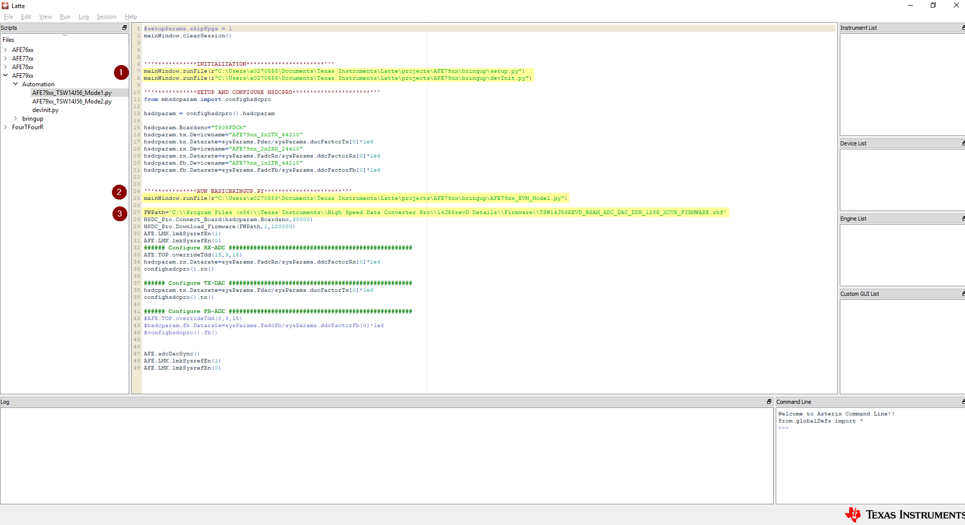
Figure 13. Item #1, #2, and #3 of the High Speed Data Converter Pro and Latte Directory
- Please enter the serial number of the TSW14J56 EVM per the highlighted location in Figure 14.
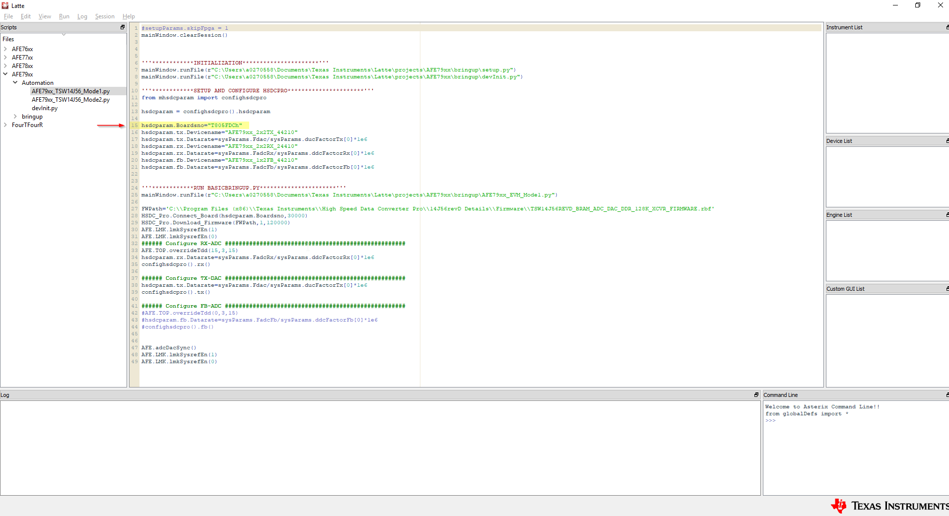
Figure 14. TSW14J56 EVM Serial Number Location
- With the AFE79xx_TSW14J56_Mode1.py highlighted, press F5 button to execute the script. The script will automate both High Speed Data Converter Pro software and Latte software to automatically bring up the JESD204B link.
- Once completed, the following two errors are expected:
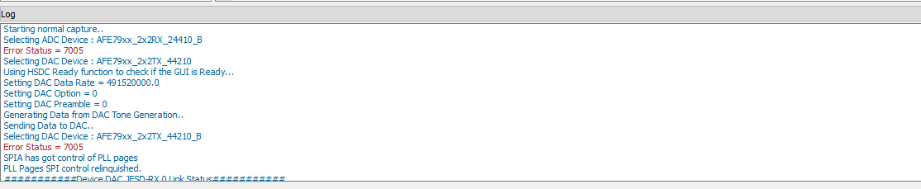

With the error message of the following:
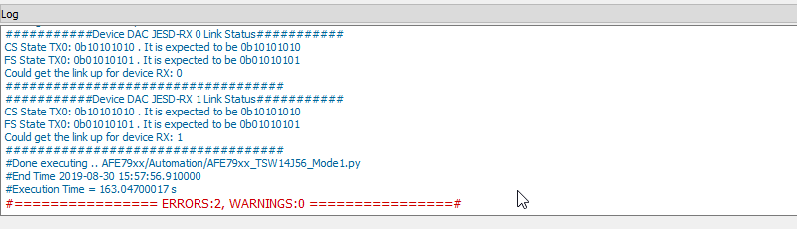
- The default AFE79xx EVM have the following RF frequency matching network
  - RXA, RXB, FBAB, TXA, and TXB = 2600MHz
  - RXC, RXD, FBCD, TXC, and TXD = 3500MHz
- The example script to change the NCO to match the default RF frequency matching network is the following:
AFE.updateTxNco(0,2600,0,0)
AFE.updateTxNco(1,2600,0,0)
AFE.updateTxNco(2,3500,0,0)
AFE.updateTxNco(3,3500,0,0)
AFE.updateRxNco(0,2600,0,0)
AFE.updateRxNco(1,2600,0,0)
AFE.updateRxNco(2,3500,0,0)
AFE.updateRxNco(3,3500,0,0)
AFE.updateFbNco(0,2600,0)
AFE.updateFbNco(1,3500,0)

Please enter the commands in the command line prompt as shown in Figure 15
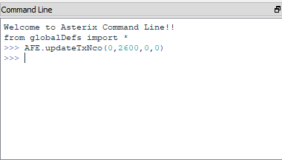
Figure 15. Command Line Prompt
Or execute AFE79xx_DC101A_NCO_Setup.py (under Automation Folder of AFE79xx) in the Latte through F5 key

- Connect the spectrum analyzer to J9 (TXA), J7 (TXB), J10 (TXC), or J8 (TXD) to monitor the TXDAC output. See Figure 16 for typical performance measurement.

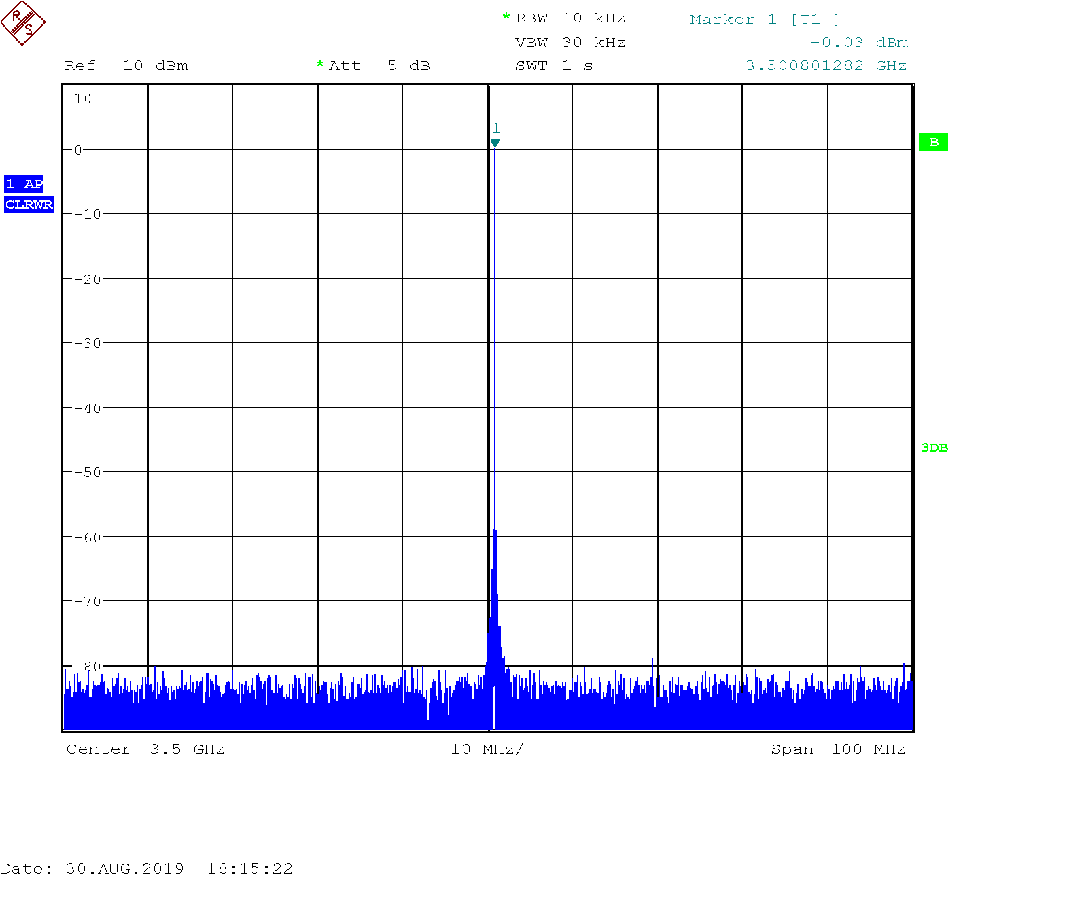
Figure 16. Typical 3.5GHz TXDAC Output

TXDAC Performance:
- TXDAC output power at J9 (TXA), J7 (TXB), J10 (TXC), or J8 (TXD) should be no less than -2dBm (depending on the SMA Cable Loss).
- Overall spur performance within 100MHz bandwidth should be less than -75dBc.

- Connect RF signal generator output to J3 (RXA_IN), J1 (RXB_IN), J4 (RXC_IN), and J2 (RXD_IN) to capture the RF input to the ADC. On the High Speed Data Converter Pro, press “Capture” button to capture the ADC data. This is shown in Figure 17.
  - For RXA_IN, RXB_IN, and FB1_IN, input 2610MHz at 0dBm
    - RXA_IN is Channel 1 and 2 in FFT Channel Selection
    - RXB_IN is Channel 3 and 4 in FFT Channel Selection
    - FB1_IN is Channel 1 and 2 in FFT under FB mode Channel Selection
  - For RXC_IN, RXD_IN, and FB2_IN, input 3510MHz at 0dBm
    - RXC_IN is Channel 5 and 6 in FFT Channel Selection
    - RXD_IN is Channel 7 and 8 in FFT Channel Selection
    - FB2_IN is Channel 3 and 4 in FFT under FB mode Channel Selection

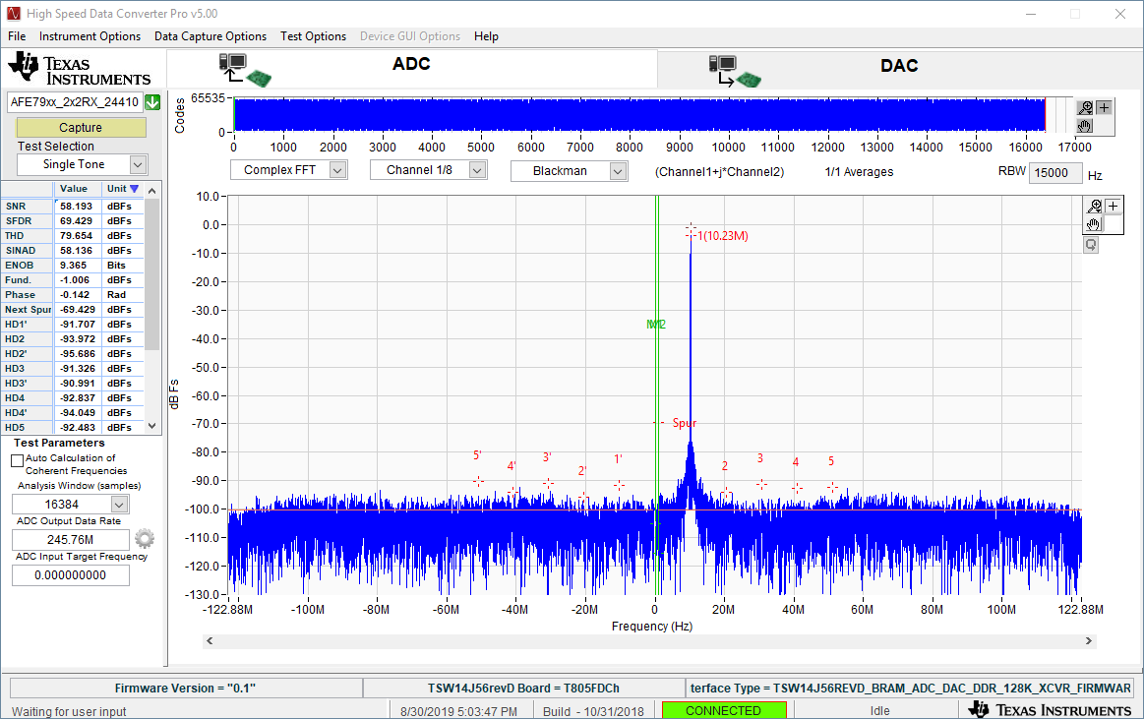
Figure 17. Capture ADC Data through "Capture" Button and Typical 3.5GHz RXADC Performance
RXADC Performance
- Fundamental power should be no less than -3dBFS, depending on cable loss.
- The SNR performance should be no less than 57.5dBFS.
- The SFDR performance should be no more than 67dBFS.

- For Feedback ADC, please execute the following commands:
###### Configure FB-ADC ####################################################
AFE.TOP.overrideTdd(0,3,0)
hsdcparam.fb.Datarate=sysParams.FadcFb/sysParams.ddcFactorFb[0]*1e6
confighsdcpro().fb()

or execute AFE79xx_FB_Capture.py through F5 key.

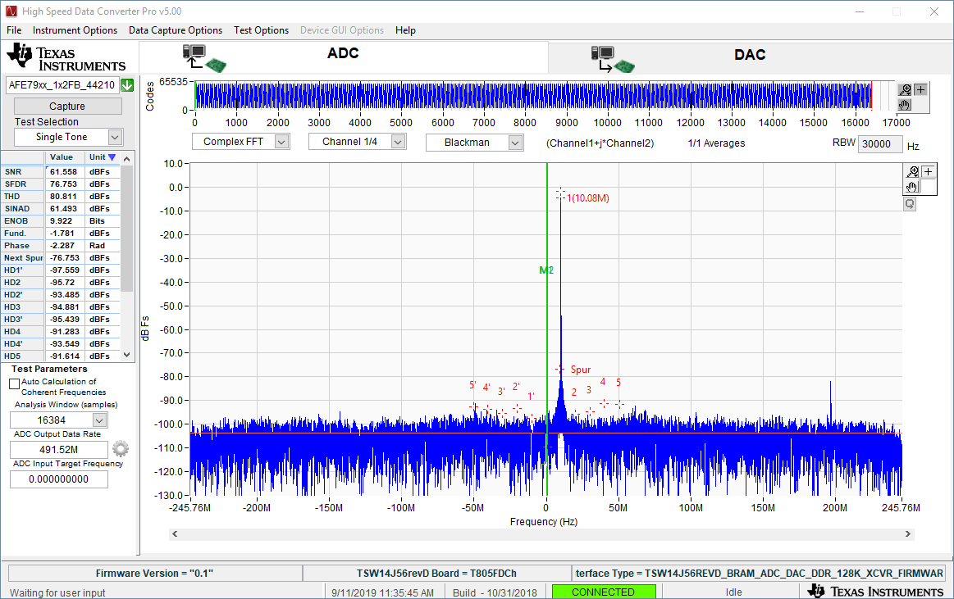
FBADC Performance
- Fundamental power should be no less than -3dBFS, depending on cable loss.
- The SNR performance should be no less than 57.5dBFS.
- The SFDR performance should be no more than 67dBFS.

If at any point you need to recover to RX and TX testing, please execute DC101_A_FB_RecoverRXTX.py through F5 key.

MATERIAL DISPOSITION & TRANSFER
  - CONFORMING MATERIAL

On the ESD bag, in text clearly visible and readable to the naked eye, add
For evaluation only; not FCC approved for resale.
This can be included on the label below or added as a separate label.
Units that have passed this test procedure shall be packaged into anti-static ESD approved bags, labeled per table below and shipped per the P.O.
Label 1  Assembly Number+Dash Number (if Applicable) | Label 2  IC Number
DC101-A | AFE7920EVM

  - NON-CONFORMING MATERIAL
If yield loss is 2% or less, scrap non-conforming units and adjust P.O. to reflect total amount shipped. If yield loss approaches, or exceeds 5%, contact EVM coordinator for assistance.

End of EVM Performance Test Procedures.

